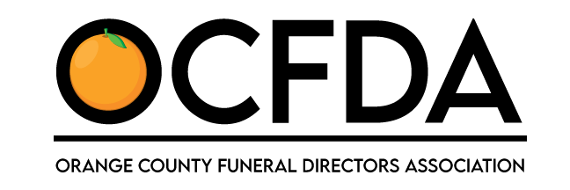
Membership Application
April 2021 – March 2022
$150

1439 W Chapman Ave #245 | Orange, CA 92868 | www.ocfda.org

If you are renewing your membership or are a new member, please complete and sign the application then follow remittance instructions below. Please remit $150 payment no later than April 30, 2021.

Firm Name___________________________________________________________ Establishment License #_______________(if applicable)

Physical Address__________________________________________________________________________________________________

Mailing Address (if different)__________________________________________________________________________________________

Contact Name______________________________________Title_________________________________Phone____________________

E-Mail Address____________________________________________ Website________________________________________________

OCFDA WALL PLAQUE Please Check One:
_____I need a wall plaque _____ I have a wall plaque, need 2021 sticker ____No plaque or sticker requested.

In order to foster and perpetuate high ethical standards in the funeral service profession, each member of this Association hereby pledges to adhere to the following rules of professional conduct.

Code of Ethics
To set an example of good citizenship by honesty and fairness in all dealings.
To perform all services in a dignified and respectful manner.
To respect each family served.
To observe all public health and state laws pertaining to the mortuary profession.
To encourage the advancement of all facets of funeral service.
To extend assistance necessary in offering services in individual cases of actual hardship.
To conduct all services in a manner that will assist in meeting the needs of the decedent, both religious and personal of all those served.
To cooperate and deal fairly with other funeral directors.
To respect the welfare of co-workers.
Signed___________________________________ Date______________________

REMITTANCE OPTIONS
1) Mail application with check to: OCFDA 1439 W. Chapman Avenue #245, Orange, CA 92868
2) *NEW* Scan & email application to ocfuneraldirectors@gmail.com then visit www.ocfda.org to pay ONLINE!

